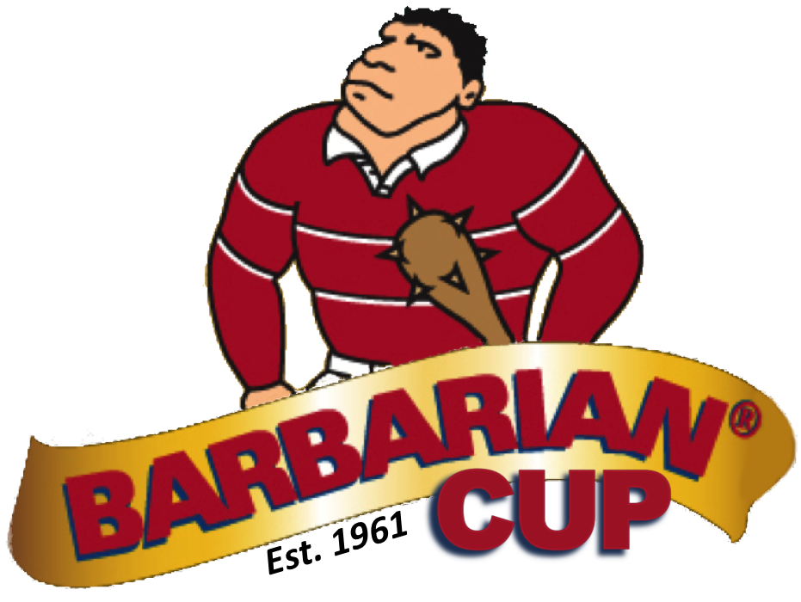
TEAM ENTRY FORM

Cheques are to be made payable to “Fergus Highland Rugby Club” and mailed to:

Connie Ryan-Bennett
Highland Rugby
12 Pine Street P.O. Box 161
Erin, ON
N0B 1T0
• Entry fee: $350 per team

• Confirmation of your team’s entry will be emailed once the team entry form, team seeding form, certificate of insurance, and cheque have been received.

• Email the certificate of insurance from your school board’s insurance company, with a minimum limit of $5 million, naming the Upper Grand School Board as an additional insured with respect to the BQAA Barbarian Cup on June 4th & 5th, 2017.

Email: cryanbennett16@gmail.com

• The junior boys’ championship draw will be composed of association champions plus wildcard entries as determined by the Barbarian Cup organizing committee.

• The junior girls’ and midget boys’ draws will be filled on a first come first serve basis.

NAME OF SCHOOL: SCHOOL BOARD: ATHLETIC ASSOCIATION: COACH’S NAME:
Coach Contact Information Email:
Cell/Home Phone: Work Phone:

TEAM ENTERED: Junior Boys Junior Girls Midget Boys JERSEY COLOURS:
(main colour & trim)

TEAM ROSTER

NAME OF SCHOOL:

COACH NAME(S):

DIVISION: Junior Boys Junior Girls Midget Boys

FIRST NAME | LAST NAME | UNIFORM NUMBER | YEAR OF BIRTH | GRADE | TRAINED FRONT ROW

